**Sprint Planning**

Two days after the end of Sprint 1, John was able to get his laptop webcam working and test the product’s AR system in Unity. This has proved successful – the camera recognises the image target and generates an AR object over the surface.

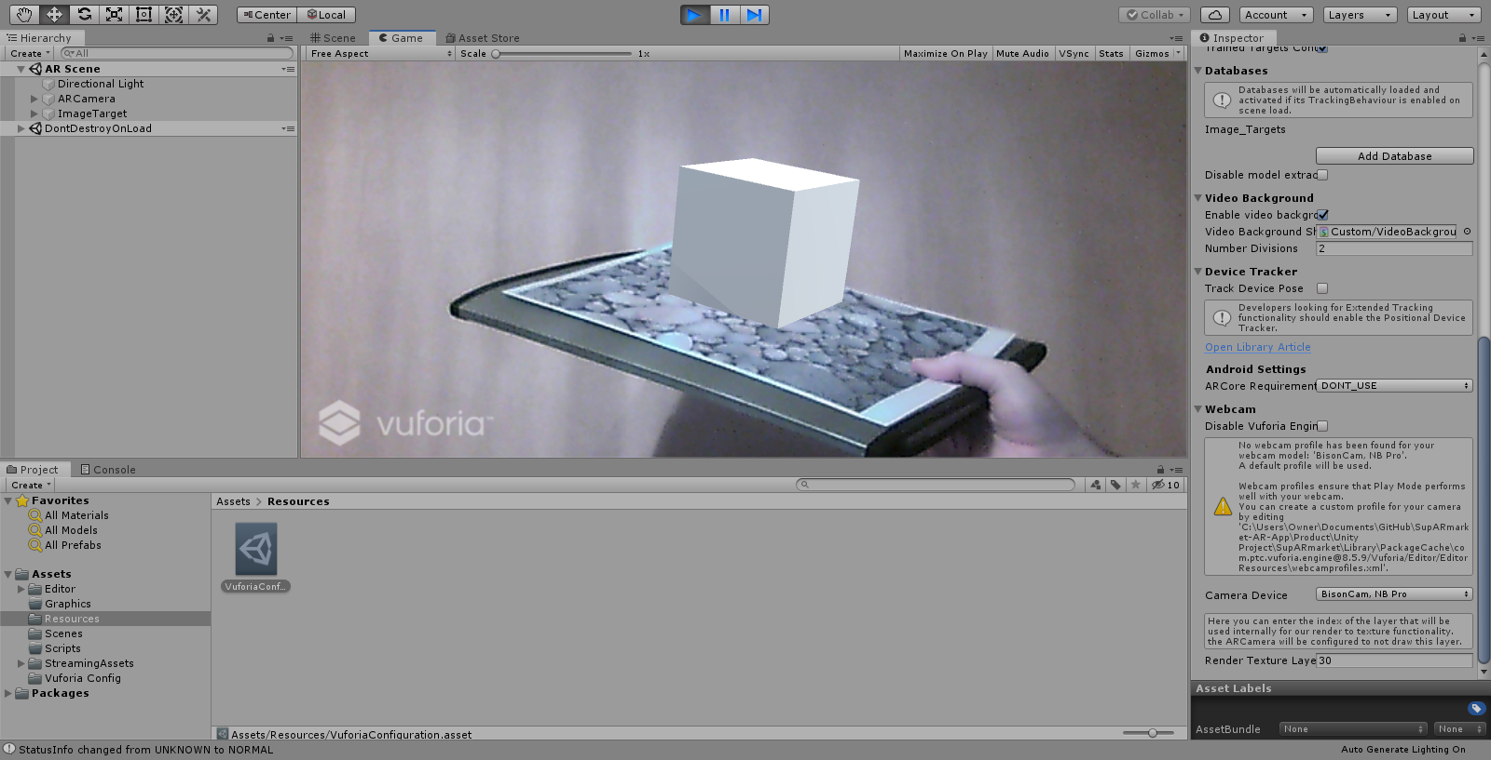

Following this, John discussed with Michaela what work she could do since he had taken on her previous task of developing the AR system.

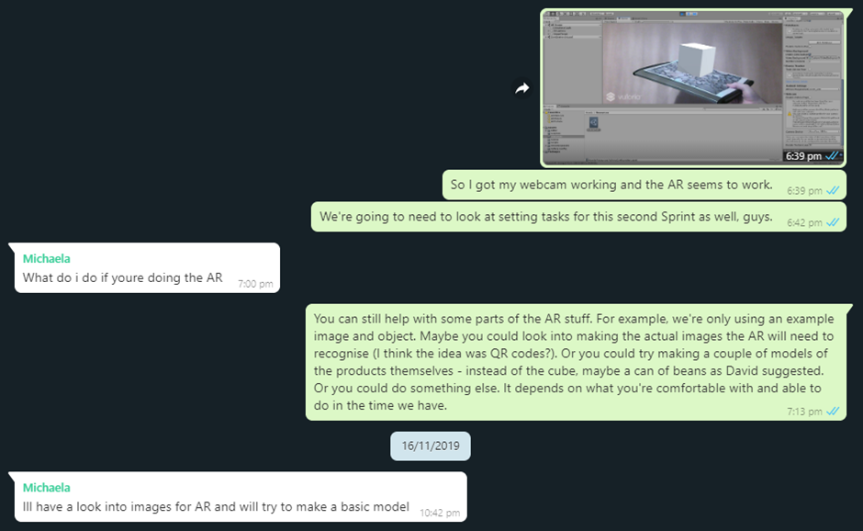

The goal for Sprint 2 was to connect the database to the Unity project and replace the image target and 3D object with assets appropriate to the purpose of the product.

The current Product Backlog and Sprint Backlog for Sprint 2 (with assigned tasks) are shown below:

|  |  |
| --- | --- |
| **PRODUCT BACKLOG** | **SPRINT BACKLOG** |
|  |  |
| **ASSIGNED TASKS** | |
| Abishek:   * Write risk assessment(s).   Alex:   * Develop basic menu/login screen.   Ann:   * Design at least 1 image/QR code to scan in store. | Michaela:   * Create at least 1 basic AR object of a store item.   John:   * Expand user database. * Add test data to database. * Connect Unity project and database. |

**Meetings/Discussions**

**MEETING (In University) – Wednesday 20th November (20/11/2019)**

**MEMBERS ATTENDED:**

Abishek, Michaela, John (Alex and Ann absent)

**WHAT HAS BEEN DONE SO FAR?**

* John successfully tested the AR functionality of the product and has been looking into how best to connect a SQL database to Unity and make the size of the project smaller on GitHub.

**ISSUES:**

* There has been no evidence of progress from any other members of the group so far.
* John raised concerns on the following two elements of the project:
  + Using MySQL as a database will require a web server to connect it to Unity and will also need a username and password, which may not work on other devices.
  + The size of the Unity project on GitHub is large, which is making pushing commits a lengthy process due to the number and size of the files.

**MEETING OUTCOMES:**

* John will research alternative methods to integrating a database into Unity and reducing the size of the Unity project.

**DISCUSSIONS (On WhatsApp) – Monday 25th November (25/11/2019) – Tuesday 26th November (26/11/2019)**

Since the meeting, John has switched to using SQLite as a database, as it is more lightweight and does not have the aforementioned drawbacks of MySQL. This has been successfully implemented within the Unity project. However, by Monday, there had been no WhatsApp communication from the other group members, so John sent a message for an update. Michaela responded that she had created a 3D model of a can of beans as was suggested.

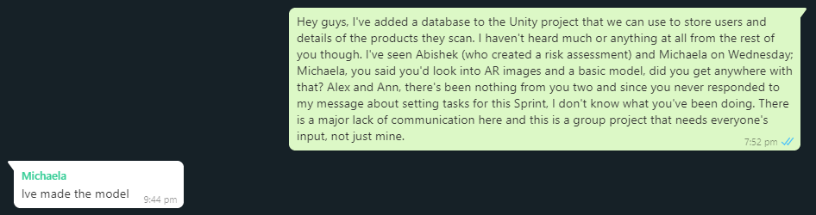

She also informed John of the software used to create the model so that it could be added to the tools/workflow list.

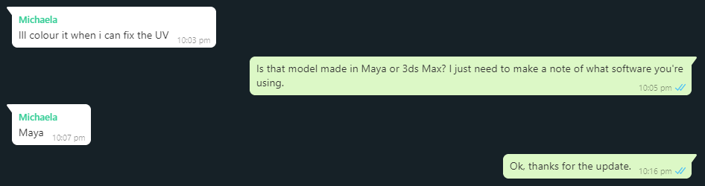

On Tuesday, Ann expressed confusion over the current roles within the group, to which John suggested creating a document to clearly define them.

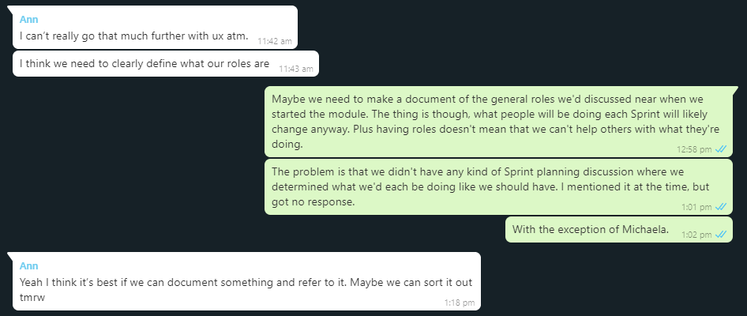

**Sprint Review**

Below is the final board at the end of Sprint 2:

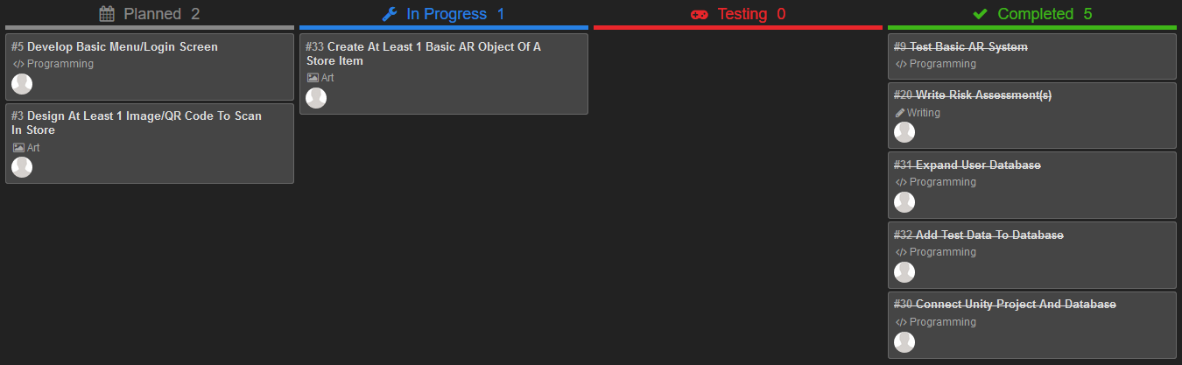

**WHAT BACKLOG ITEMS HAVE BEEN “DONE”?**

* Test basic AR system.
* Write risk assessment(s).
* Expand user database.
* Add test data to database.
* Connect Unity project and database.

In addition, John has added a .gitignore file to the Unity project. When making a commit to GitHub, this will ignore many of the unnecessary local files that do not need to be shared for others to load the project. This reduces both the size of the overall project and the time to upload changes.

**WHAT BACKLOG ITEMS HAVE NOT BEEN “DONE” AND WHY?**

* Develop basic menu/login screen – No communication from Alex.
* Design at least 1 image/QR code to scan in store – Ann had instead worked on UX-related elements of the project.
* Create at least 1 basic AR object of a store item – Michaela was working on this, but appeared to not have completed it, nor uploaded what she currently had onto GitHub.

**WHAT TO DO NEXT?**

For the next Sprint, catching up on incomplete work will again be necessary. Now that a working database has been successfully implemented into the project, users will now need be able to directly interact with it via a login system. In addition, the app still requires both image targets/QR codes and 3D models of various store items to replace the test assets.

**Sprint Retrospective**

Similarly to Sprint 1, communication has continued to be an issue within the group. For the entire Sprint, two members have failed to communicate through WhatsApp and only two completed their tasks. Due to the confusion caused by who is doing what within the project, it is evident that roles will need to be more clearly defined, perhaps in writing. They may also need to be changed, as for two consecutive Sprints, the task to develop a basic menu screen has not been completed.